Deadlines and submission information listed on Canvas
Total Points: 25 Points
Problem 1 [12 pts]: Identifying a planar mechanism
- Make a kinematic sketch (a.k.a. kinematic diagram) of the mechanisms in the links listed below. Label all links and joints using the formalism developed in class. Indicate the grounded link, and whether each joint is prismatic (sliding) or rotational. (4 pts each)
Oil Well Drilling: https://www.youtube.com/shorts/KmBP2jRFw7I Hint, treat the samson post as ground and neglect the cable on the right side of the machine.

Trebuchet Mechanism:
https://www.youtube.com/watch?v=r1BGNkYDJuI
Hint: For the purposed of this question, we can ignore the sling and projectile

- Use Gruebler’s equation to calculate the Degrees of Freedom of each mechanism. Justify why your answer makes sense. Add the calculation to the Box. (2 pts each)
Problem 2 [13 pts]: Understanding degrees of Freedom
- How many independent coordinates are needed to define any point in a plane (2D space)? (2 pt)

- Calculate the degrees of freedom for each of the three planar linkages below. Show work (3 pt)
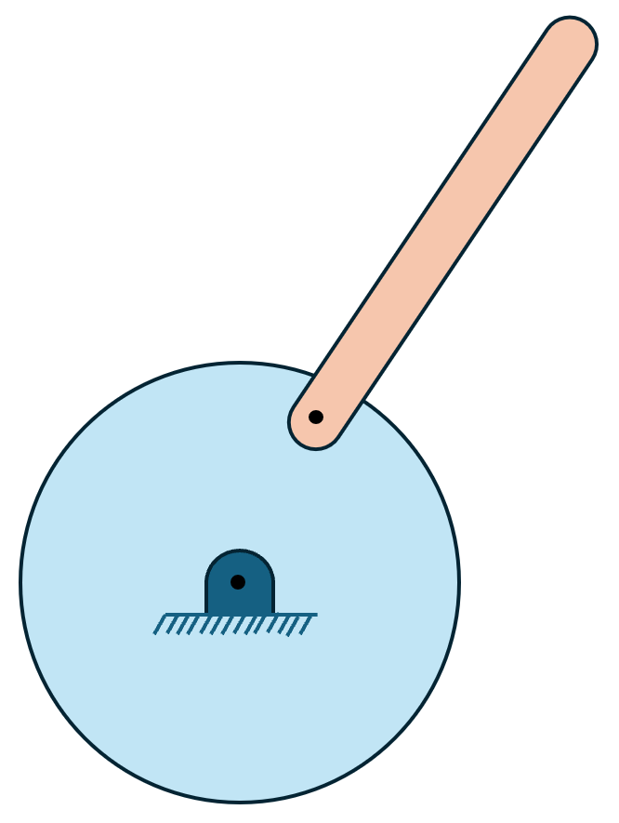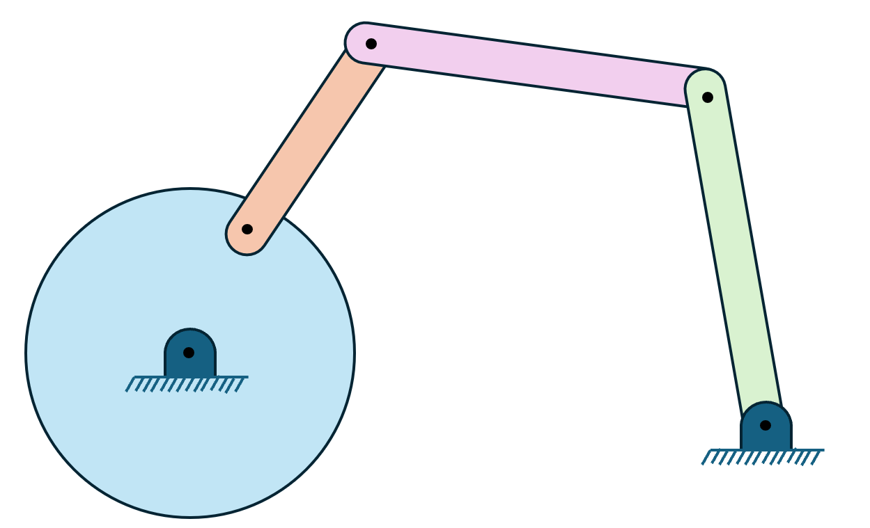

- (i) What is a degree of freedom? Explain your answer using simple language, as if your audience was a five-year-old child (2 pt)

(ii) Describe what it means for a linkage to have more degrees of freedom than the dimension of the space it lies in. (2 pt)

- Using a kinematic diagram, give an example of a linkage that would have 0 DOF. Give an example of a linkage with -1 DOF. (2 pt)

- How would you turn a 0 DOF linkage into a 1 DOF linkage? Draw an example with a specific linkage. Identify what transformation rule corresponds with your solution. (2 pt)

Select one of the following options:
- My answer was created by a Gen AI algorithm, and I have not modified it
- My answer was created by a Gen AI algorithm, and I have made some minor changes.
- My answer was created by a Gen AI algorithm, and I have made major changes.
- My answer was created solely by myself.
- If I used Gen AI, I used ___ (name of program).

